

CSA0501-DATABASE MANAGEMENT SYSTEMS

LAB EXPERIMENTS DATE: 27/07/2026

EXPERIMENT 11 – Database with AUTO_INCREMENT

AIM: To create and use an AUTO_INCREMENT sequence in the pet_details table.

PROCEDURE:
- Select the required database using the USE command.
- Display the existing records from the pet_details table.
- Apply the AUTO_INCREMENT property to the sno column.
- Insert a new pet record without specifying the sno.
- Insert another record by manually specifying the sno.
- Verify the automatically generated and manually entered values.
- Remove the AUTO_INCREMENT property from the sno column.
PROGRAM:

1. Display all records:

USE pet_management;

SELECT * FROM pet_details;

OUTPUT:

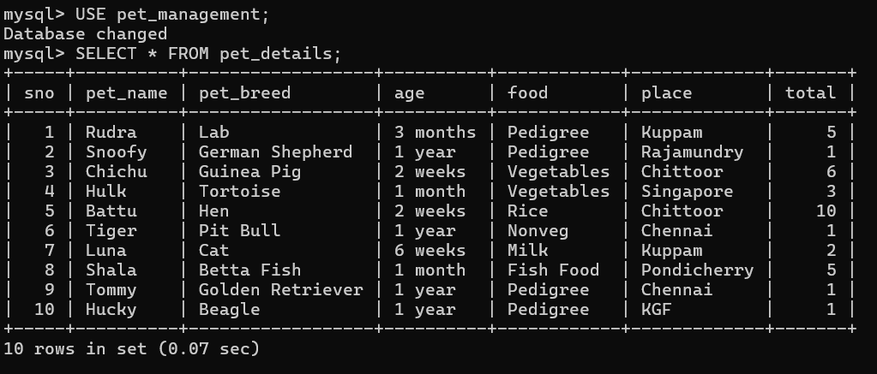

2. Add AUTO_INCREMENT to sno
ALTER TABLE pet_details
MODIFY sno INT AUTO_INCREMENT;
OUTPUT:

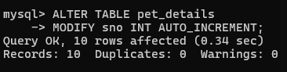

3. Populate register number using AUTO_INCREMENT
INSERT INTO pet_details
(pet_name, pet_breed, age, food, place, total)
VALUES
('Bruno','Labrador','2 years','Pedigree','Kuppam',2);
SELECT * FROM pet_details;

OUTPUT:
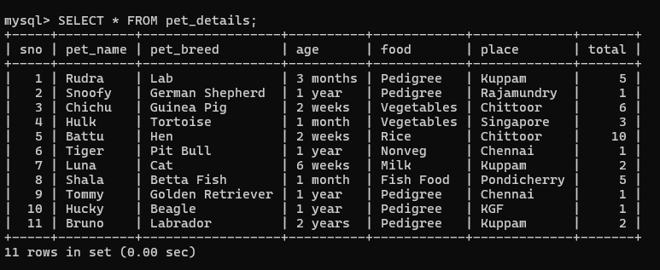

4. Manually populate register number
INSERT INTO pet_details
(sno, pet_name, pet_breed, age, food, place, total)
VALUES
(12,'Rocky','Beagle','1 year','Rice','Chennai',3);
SELECT * FROM pet_details;

OUTPUT:

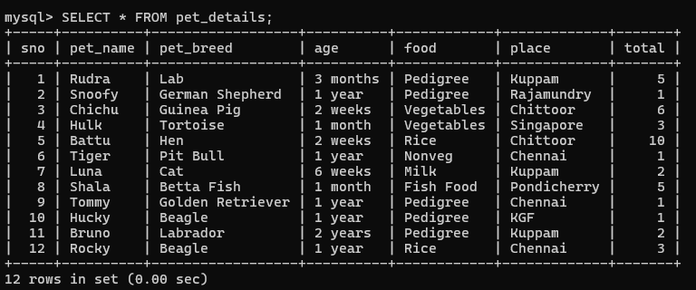

5. Drop AUTO_INCREMENT
ALTER TABLE pet_details
MODIFY sno INT NOT NULL;
DESC pet_details;
OUTPUT:

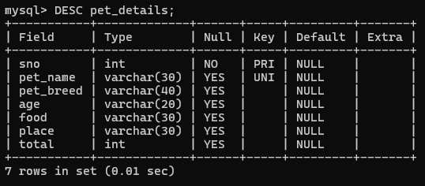

RESULT: The records from the tables are displayed using auto_incrementsequence on the given relation.

